Syntactic Analysis [ongoing]

Looking at syntactic complexity:

Indicator of complexity – number of verbs per sentence

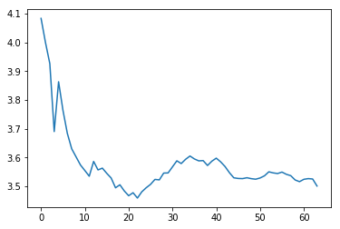

Number of verbs per sentence average, across all speeches

(number of verbs is a ROUGH estimate for amount of embedding)

🡪embedding is clause within clause. Clause is subject and verb. Subject can be implicit

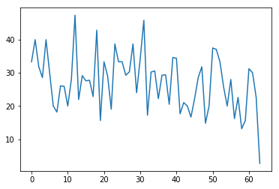

Proportion of sentences in speech which have more than 4 verbs

Slight trend downwards

* These two graphs show us:

1. lowering average verb count per sentence
2. not only due to more short sentences... slightly lowering proportion of sentences with more than 4 verbs

now looking at parsing sentences and more formally calculating amount of embedding. S / SBAR counting.